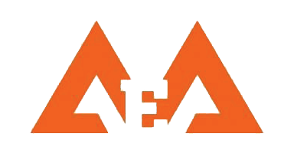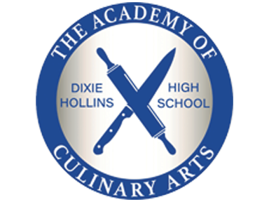

Hollins High School

Application Program Tour & Shadow Information

# 

# Shadow Information

8th grade students can shadow an

Academy Program student to see

campus life on a typical school day.

Shadowing opportunities are available

by appointment only.

Go to the Hollins website

<https://forms.office.com/r/fgGuKhVxug>

for an appointment.

Availability may be limited.

[***www.pcsb.org/dixie-hs***](http://www.pcsb.org/dixie-hs)

***Academy of Culinary Arts***

***Academy of Entertainment Arts***

***Cambridge / AICE***

# Shadow Dates by appointment

*Monday and Thursday*

* October 3, 5, 17, 19, 24, 26, 31
* November 2, 7, 14, 16, 30
* December 5, 12, 14

# Tour Dates by appointment Most Wednesday’s 7:30 a.m. – 8:30 a.m

# Oct 4, 18, 25

# Nov 1, 15, 29

# Dec 6, 13